3 Reasons to Reduce Your Meat Intake

1.) Produces High Greenhouse Gas Emissions

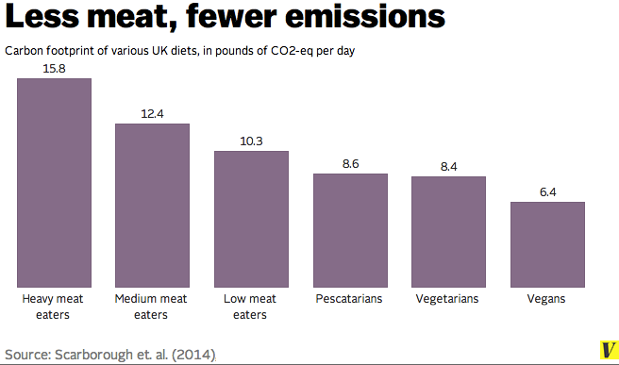
Note: In the study, "heavy meat eaters" are defined as anyone who eat more than 3.5 ounces of meat per day. "Medium meat eaters" eat between 1.7 and 3.5 ounces. "Low meat eaters" eat fewer than 1.7 ounces per day. "Pescatarians" are vegetarians who also eat fish.
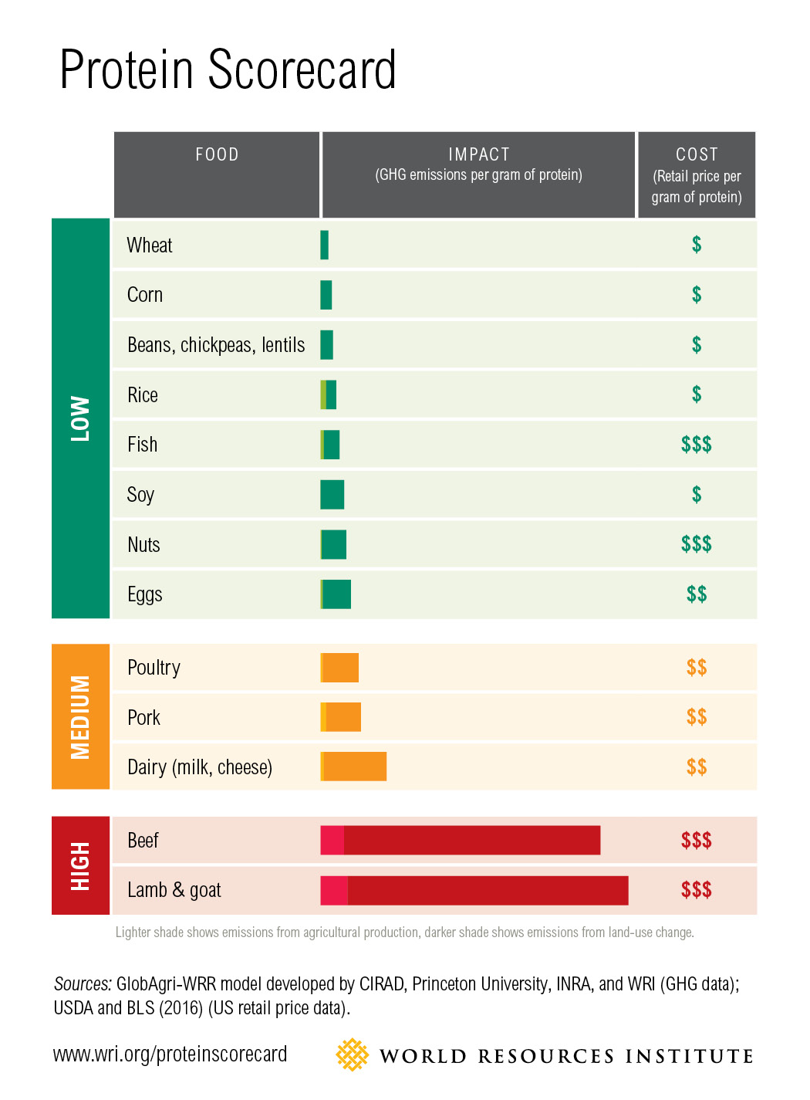

2.) Requires More Natural Resources

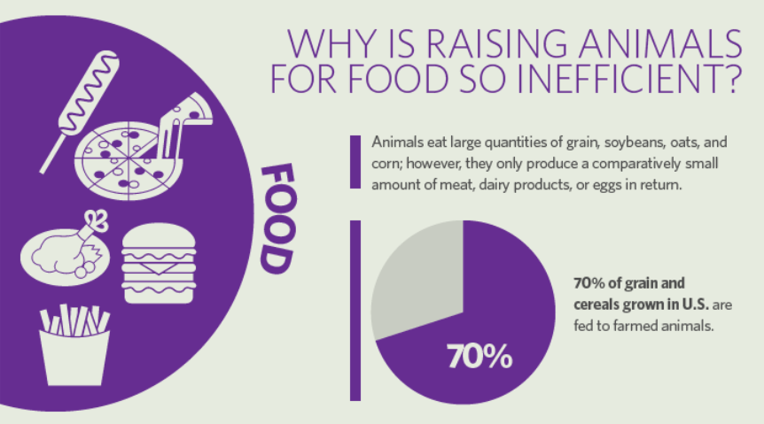
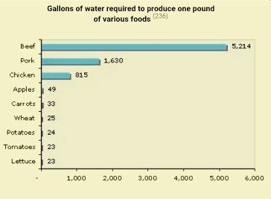
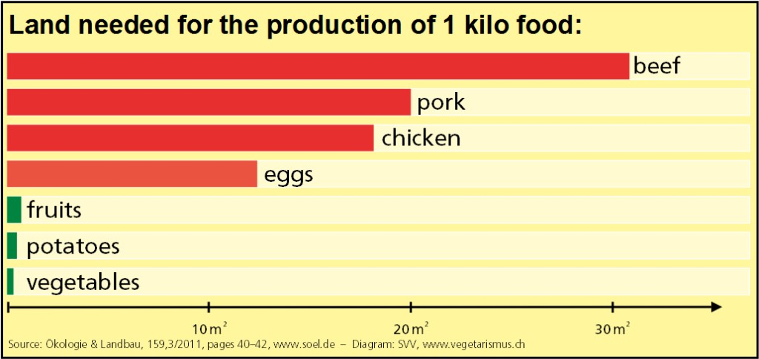
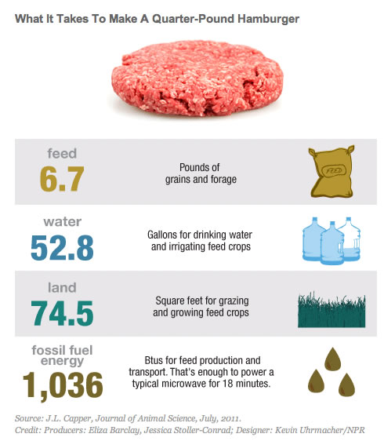
3.) Too Much Protein in Western Diets/Health Risks Associated with Processed Red Meat

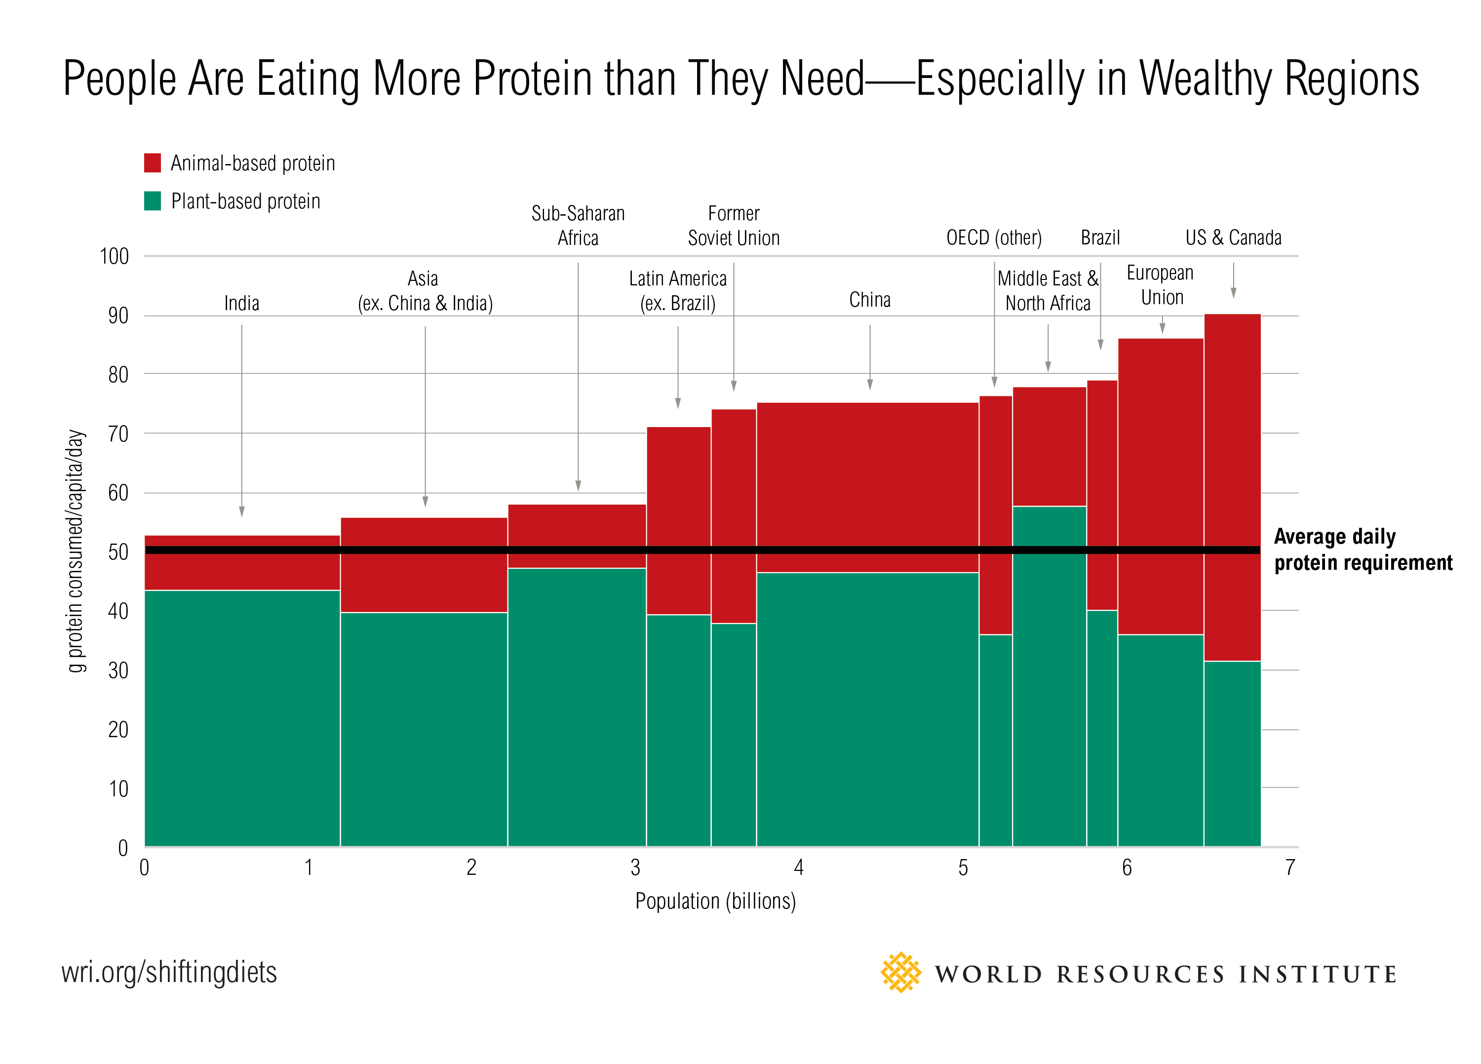

Protein substitutions for
red meat that can reduce your early mortality risk
Substitute a daily portion of red meat with a healthier protein source to reduce mortality risk by the indicated amount:
Red Meat Substitute | Reduced Risk
Fish | -7%
Legumes, low-fat dairy | -10%
Poultry, whole grains | -14%
Nuts | -19%

Want to work on reducing your red meat intake? Try some of these initial steps:
- Try Meatless Mondays (or use a red meat substitute like chicken, fish, lentils)
- Check out some vegetarian cookbooks from your local library

For further reading, check out some of these articles:
Eat Less Meat to Avoid Dangerous Global Warming
Giving Up Beef Will Reduce Carbon Footprint More Than Cars
Red Meat Shortens Your Life Span
Supermarket Meat Still Superbugged, Federal Data Show

